CURRICULUM VITAE
KAREN E. TERRY

PROFESSIONAL
EXPERIENCE July 1995 - Present
Shareholder at Searcy Denney Scarola Barnhart & Shipley, P.A., West Palm Beach, Florida
Litigate Plaintiff personal injury, medical malpractice, wrongful death, and product liability cases.

Tries complex jury trials, performs extensive depositions all over the country, and settles thousands of cases.

PROFESSIONAL Board Certified Civil Trial Lawyer, 2016-current

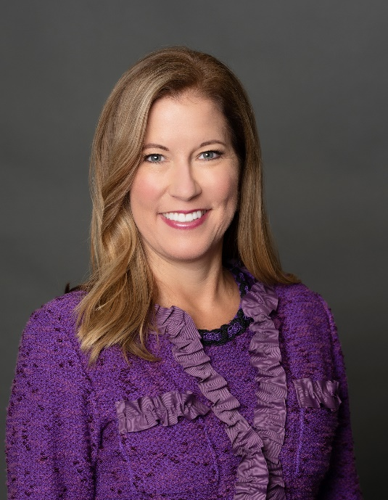
Board Certified Specialist in Healthcare and Medical Malpractice, 2016-current

2022 Lawyer of the Year Award in Medical Malpractice, by Best Lawyers in America

Recognized in 5 categories as Best Lawyer in Personal Injury, Medical Malpractice, Product Liability, Mass Torts, and Professional Malpractice

ABOTA Trial Lawyer of the Year, 2022

American College of Trial Lawyers, 2020

National Trial Lawyers, selected as top 100 trial lawyers in US

Voted as Top 50 Women Attorneys in Florida

2019 Legal Elite Hall of Fame

2019 Super Lawyers

Top Lawyers 2019 by Palm Beach Illustrated

International Society of Barristers, 2018, elected to Foundation Board 2022

Supreme Court of Florida Certified Circuit Mediator, 2018 Qualified Arbitrator, 2023

American Board of Trial Advocates (ABOTA), 2009 – Present; 2018 Palm Beach Board Member; 2019 Vice President; 2020 President Elect

Lawyer of the Year Award, 2017, in Mass Tort Litigation/Class Actions-Plaintiffs, by Best Lawyers in America

Selected as Top Lawyer by The American Lawyer, 2017

Chosen as 1 of 10 Best Female Personal Injury Attorneys by American Institute of Personal Injury Attorneys, 2016

2016 West Palm Beach Product Liability Litigation Lawyer of the Year

Named Best Lawyers 2016 Lawyer of the Year in Product Liability Litigation

Named as 2015 Lawyer of the Year in Mass Torts/Class Actions

Top Plaintiff’s Verdict in 2015 per Courtroom View Network

Florida Verdicts Hall of Fame, Curtis v Villas, Premises Liability 2014

Chosen as one of TOP Attorneys to Watch in 2014

Selected by American Lawyer Media and Martindale-Hubbell as one of the “2013 Top Rated Lawyers” in Health Care.
Honored as Member-Premiere International Who’s Who Registry of Outstanding Professionals, 2010-Present

Selected by Law Dragon as Top 500 Lawyers in the US, 2010

Chosen as South Florida Top Lawyers, 2010 – Present

Selected as a member of Florida Legal Elite, 2009 - Present

Selected as Florida Super Lawyer, 2009 - Present

Honored as Top Lawyer in South Florida Legal Guide, 2009 - Present

AV Preeminent rated by Martindale Hubbell, 2009 - Present

Selected Most Effective Lawyer in 2007 by Daily Business Review in products liability.

Member of Million Dollar Advocates Forum for Top Trial Lawyers in America, 1996 – Present.

Selected as one of the top five litigators under the age of 40 by Florida Trend Magazine and South Florida Legal Guide.

Member of American Association of Justice, 1996 - present

Member of Florida Bar Association, 1995 – Present.

Member of Florida Justice Association, 1995 - Present

Member of Palm Beach County Bar Association, 1995 –Present.

Member of Palm Beach County Justice Association, 1995 – Present.

Member of American Bar Association, 1994 – Present.

Mensa, 1994 – Present.

LEGAL December 1994
EDUCATION University of Florida College of Law, Gainesville, FL
Dean's List - Honors Student
Student Honor Court, Attorney General

POST LEGAL June 1995
STUDIES University of Florida, Gainesville, FL
Completed a Master's Degree in Communications Law at the University of Florida

UNDERGRADUATE May 1991
EDUCATION Duke University, Durham, NC
Bachelor of Arts Degree in Political Science, 1991
Graduated in three years with High Honors
Dean's List with Distinction
Golden Key National Honor Society
Political Science National Honor Society
Bench and Bar Legal Society - Vice President
Chairperson of the Panhellenic Judicial Board
Pi Beta Phi Sorority
Also took courses for credit at the London School of Economics, University of Madrid, Harvard, Georgetown, and Tufts University

PUBLICATIONS "Video Games, Violence, First Amendment Protection, and Regulation"; University of South Carolina Communications Journal, 1995.

EARLY Graduated 1988 with High Honors from Pine Crest
BACKGROUND Preparatory School, Fort Lauderdale, FL

PERSONAL Strong in written and verbal communications and debating. Working knowledge and use of the Spanish language. Interests include running, yoga, rock climbing, paragliding, and travel.

NOTABLE VERDICTS

Jury Verdict Award in 2021 in Medical Malpractice Case in the amount of $2,440,000.00.

Jury Verdict Award in 2019 in a Wrongful Death Crash in federal court in the amount of $5,000,000.00.

Jury Verdict Award in 2015 in a Survivor Automobile Crash Case in the amount of $6,160,546.04

Jury Verdict Award in 2015 in a Survivor Case Medical Malpractice Case in the amount of $8,540,786.90. Ranked as #1 trial of 2015 by Courtroom View Network

Jury Verdict Award in 2013 in a Wrongful Death Case in the
amount of $12,065,000.00

Jury Verdict Award in 2007 in a Misfill Prescription Case in
the amount of $25,850,583.77

Jury Verdict Award in 2004 in a Medical Malpractice Case in
the amount of $2,386,026.99

Jury Verdict Award in 2002 in an Automobile Crash Case in
the amount of $1,038,000.00

Jury Verdict Award in 1996 in a Medical Malpractice Case in
the amount of $1,854,661.00

